Nucha Powanusorn 51000289

Sammy Gulipalli 57159444

Paco Chan 82033788

Soseki Kashimori 85121903

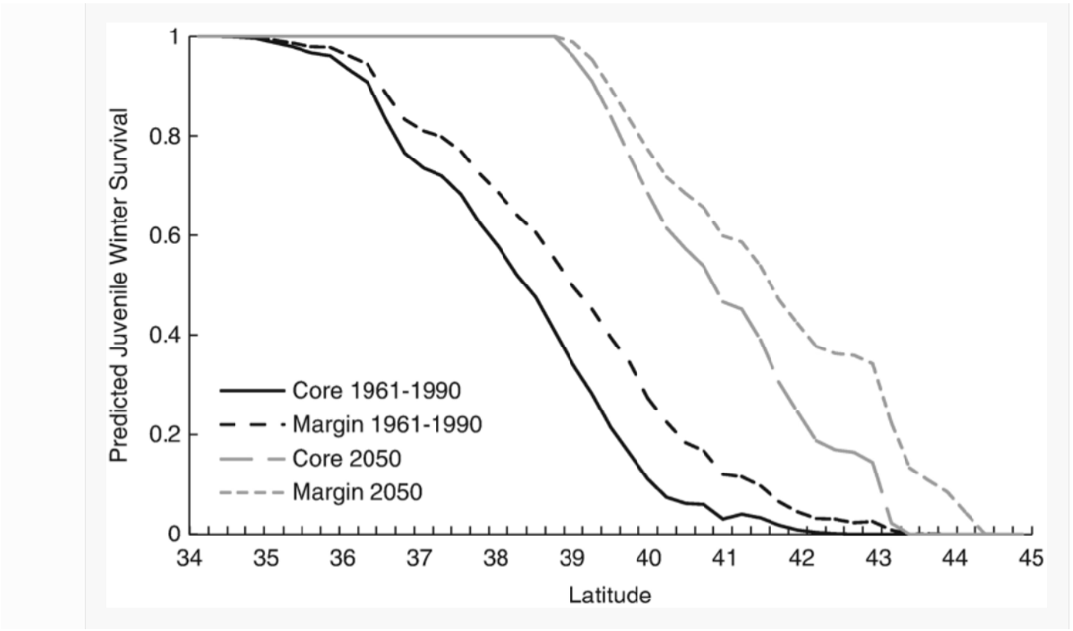

**Explain the axes**

The vertical axis represents the rate of winter survival for the Japanese honeysuckle. The horizontal axis represents the latitude where the honeysuckle is attempting to grow.

**Describe the trends in data**

Firstly, we can see that we are expecting the Japanese honeysuckle to migrate to higher latitudes over time. We can also see that in general, the margins of the honeysuckle can survive at higher latitudes compared to the core. A trend that holds across time and core/margin is that the higher the latitude, the less likely the honeysuckle juveniles are able to survive in the winter.

**Why would the values be different at the margin and the center of each range?**

The core will contain the highest density of the plants, meaning that there will be increased competition for survival and thus a lower survival rate at the same latitude. On the other hand, those at the margins will have less competition from others and will therefore have a higher survival rate.

**Explain what is predicted to happen by 2050.**

By 2050, the honeysuckles will expand in range from lower latitudes to higher latitudes. As climate change increases global average temperatures, we can expect winters to be more mild compared to before. As higher latitudes generally have colder / harsher winters, winters that are more mild will allow juvenile honeysuckles to survive through the winter as it is now less cold, despite the lack of adaptations in their structure.

It is possible that over time, the honeysuckle has developed some adaptations that allow it to survive harsher conditions, but this is unlikely given the prevailing climate change conditions that result in milder winters.